**Name _____________________**

**Human Body Fact Sheet**

|  |  |  |  |  |
| --- | --- | --- | --- | --- |
|  |  |  |  |  |

Use the information that you will find on the web site "A Look Inside the Human Body" to complete the following questions.

1.  What are the four major systems of the human body?

_______________________                 ______________________   
_______________________                 ______________________

Skeletal System

|  |  |  |
| --- | --- | --- |
|  |  |  |

2.  What are the 3 major jobs that our skeleton does?

_______________________________          ______________________________ _______________________________

3.  How many bones does a newborn baby have?

____________________

4.  How many bones does an adult have?

_____________________

5. Why does a baby have more bones than an adult?

_____________________________________________________________________________________________

Respiratory System

|  |
| --- |
|  |

7. What does the body take in when we breathe? _________________________________

8. What are the small air balloons in our lungs called? _________________________________

9. What color do blood cells turn when they pick up oxygen from the alveolies? ______________

10. What is the name of the muscle that controls the breathing process? ______________________

11. What is the highest recorded "sneeze speed"? __________________________

12. Label this picture of the Respiratory System.

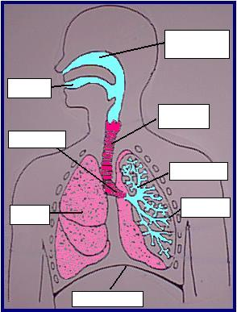

Circulatory System

|  |  |
| --- | --- |
|  |  |

14. Where is the heart positioned? ____________________________

15. Complete these sentences:

* Blood that is rich in oxygen appears __________________
* Blood that is poor in oxygen appears _________________
* Blood leaving the heart travels in ___________________
* Blood returning to the heart travels in _________________

16. How many blood cells in a droplet of blood? _________________________________

17. How long do blood cells live? _________________________________

Digestive System

|  |
| --- |
|  |

18. How long is our digestive system? _______________________

19. What mixes with the food when it is in the stomach? ________________________________

20. From the small intestine, food is broken down and goes either into the ___________________ or into the ___________ ____________________.

21. How much saliva is produced by the body each day? _____________________

22. Label this picture of the Digestive System.

